AIR UNIVERSITY, ISLAMABAD
Department of Computer Science
CS-301L: Full Stack Web Development (Lab)
Lab 09: Security, Middleware, Guards and Pipes
Student Name: | Rehan Shoukat
Registration No: | 242711
Course: | CS-301L: Full Stack Web Development (Lab)
Lab Topic: | Lab 09 - Security, Middleware, Guards and Pipes

Task 1: Secure Application Bootstrap (3 Marks)
Application bootstrap in main.ts configured with Helmet security headers, CORS restricted to http://localhost:5173 only, and global ValidationPipe with whitelist, forbidNonWhitelisted, and transform enabled.
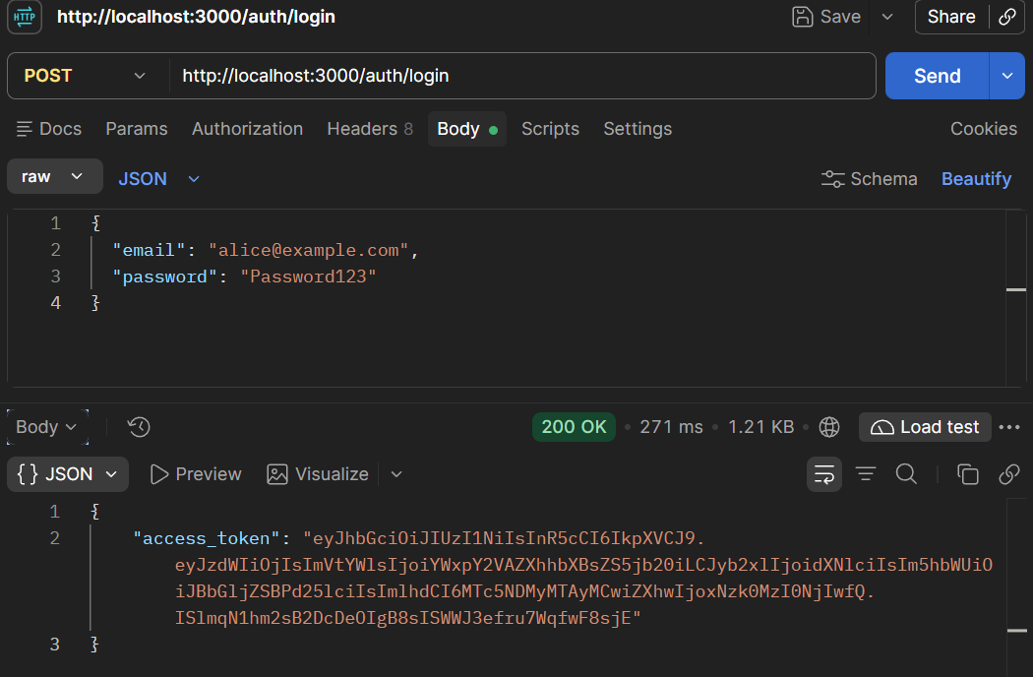
Figure 1.1: POST /auth/login — 200 OK response showing the returned JWT access_token
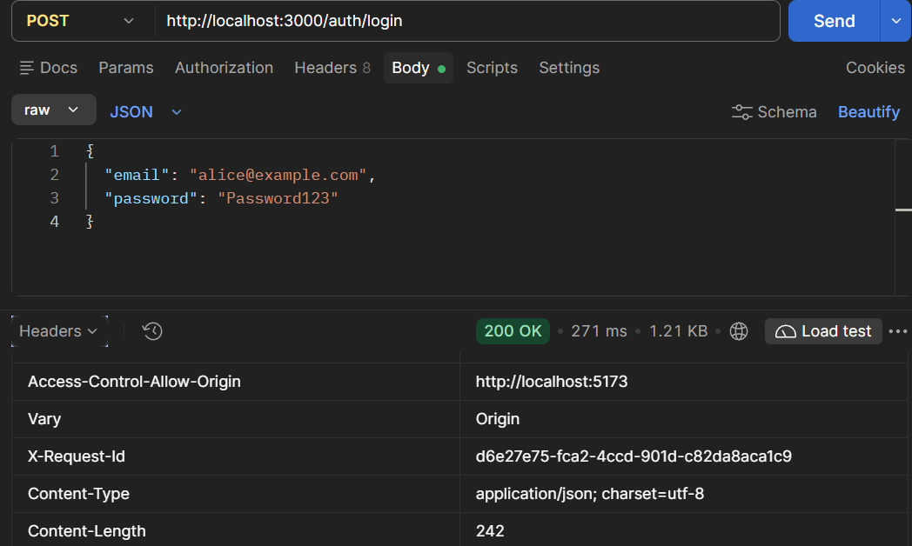
Figure 1.2: Response Headers — X-Request-Id UUID, Access-Control-Allow-Origin: http://localhost:5173, x-content-type-options: nosniff
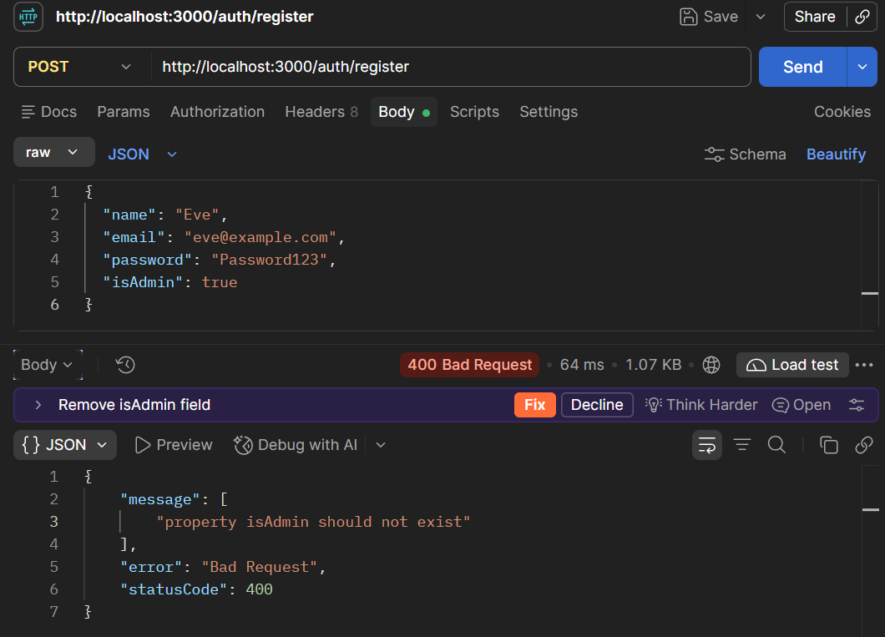
Figure 1.3: POST /auth/register with isAdmin: true rejected with 400 Bad Request (property isAdmin should not exist)
Task 2: DTO Validation and Update Endpoint (4 Marks)
CreateNoteDto extended with optional tags (max 5, max 20 chars each), UpdateNoteDto via PartialType, and PATCH /notes/:id with PositiveIntPipe and ownership/admin permission checks.
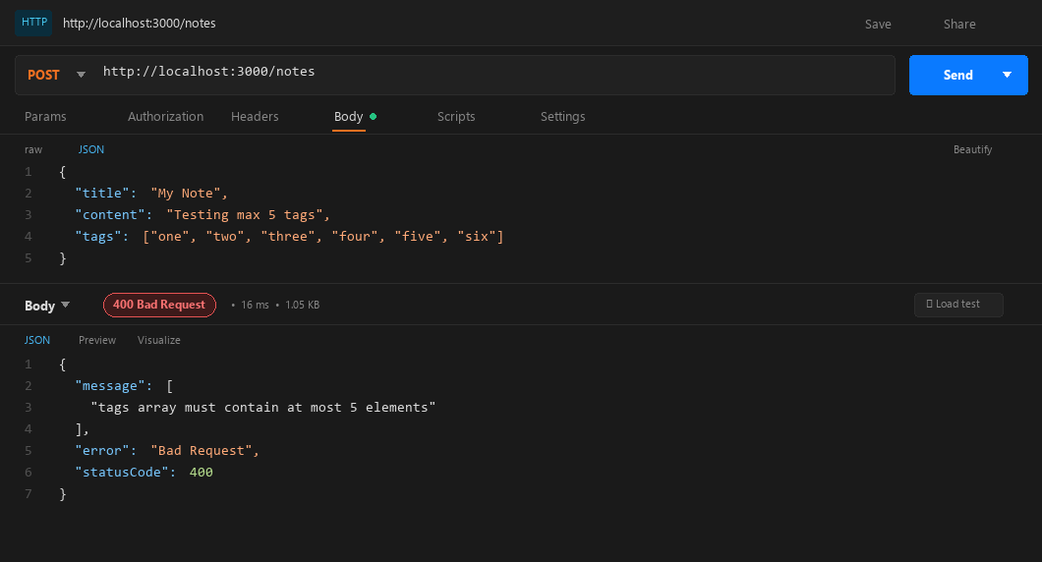
Figure 2.1: POST /notes with 6 tags — 400 Bad Request (@ArrayMaxSize(5) validation fails)
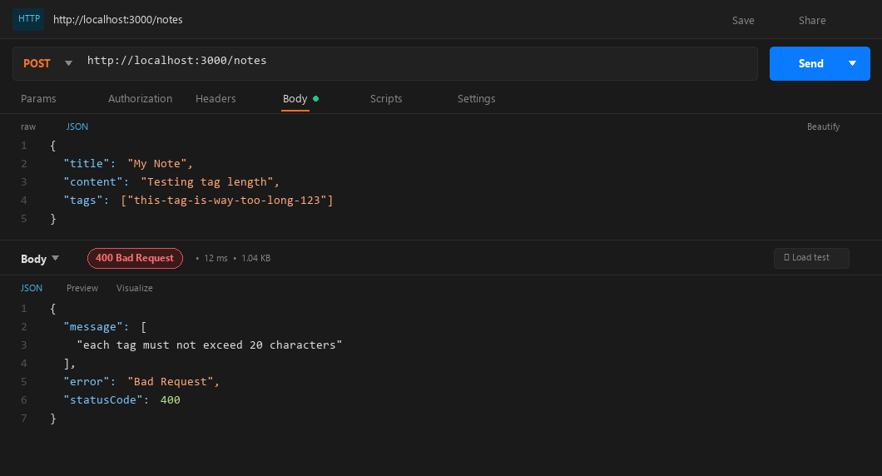
Figure 2.2: POST /notes with a 25-character tag — 400 Bad Request (@MaxLength(20) validation fails)
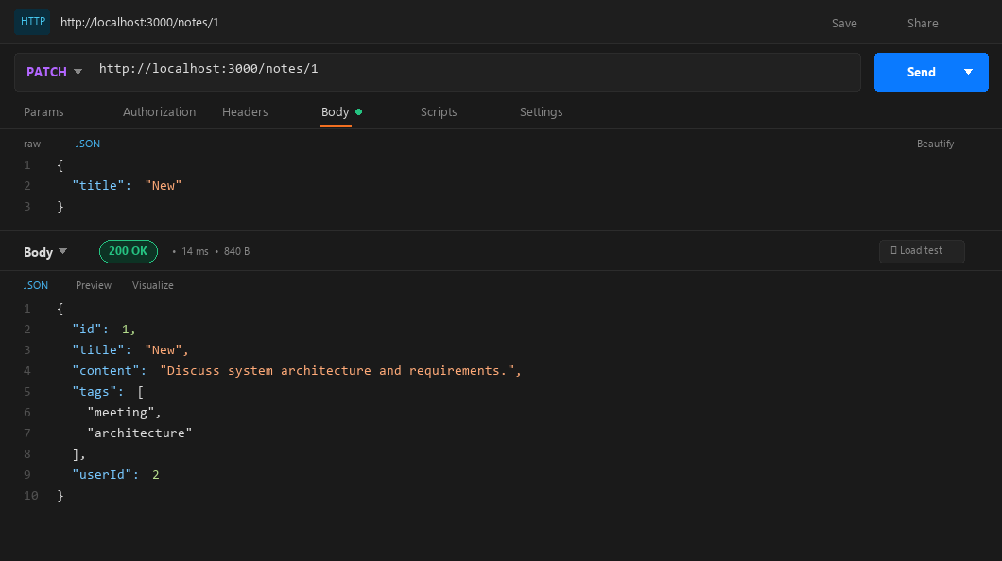
Figure 2.3: PATCH /notes/1 by owner (Alice) — 200 OK, only the title changed to 'New', rest preserved
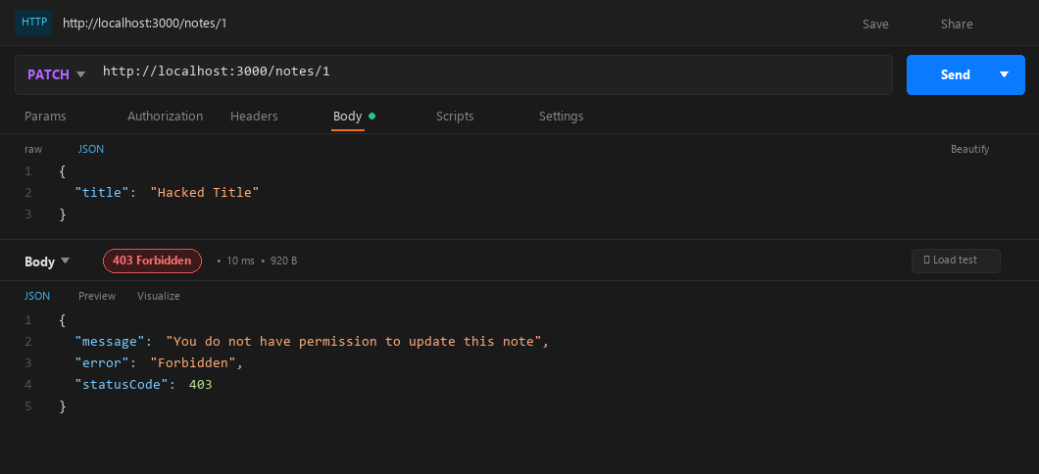
Figure 2.4: PATCH /notes/1 by another user (Bob) — 403 Forbidden (not the note owner)
Task 3: Custom Middleware, Request ID (3 Marks)
RequestIdMiddleware generates a unique UUID via crypto.randomUUID(), attaches it to the request object, and sends it back in the X-Request-Id response header. LoggerMiddleware prepends [<id>] to every terminal log line.
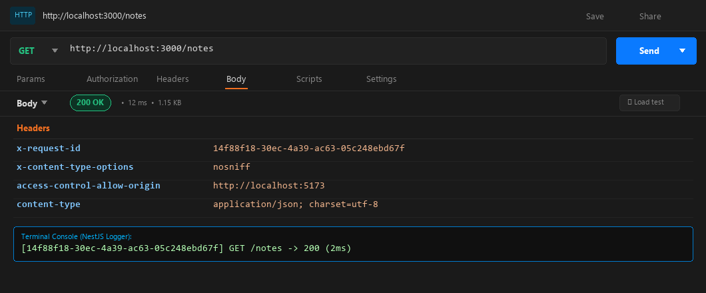
Figure 3.1: GET /notes — Response Headers showing X-Request-Id UUID; terminal log confirms [uuid] GET /notes -> 200
Task 4: Custom Pipe, SortOrderPipe (3 Marks)
SortOrderPipe parses the 'order' query param (asc/desc, case-insensitive), defaults missing values to 'asc', and throws 400 Bad Request with the message 'order must be asc or desc' for any other value.
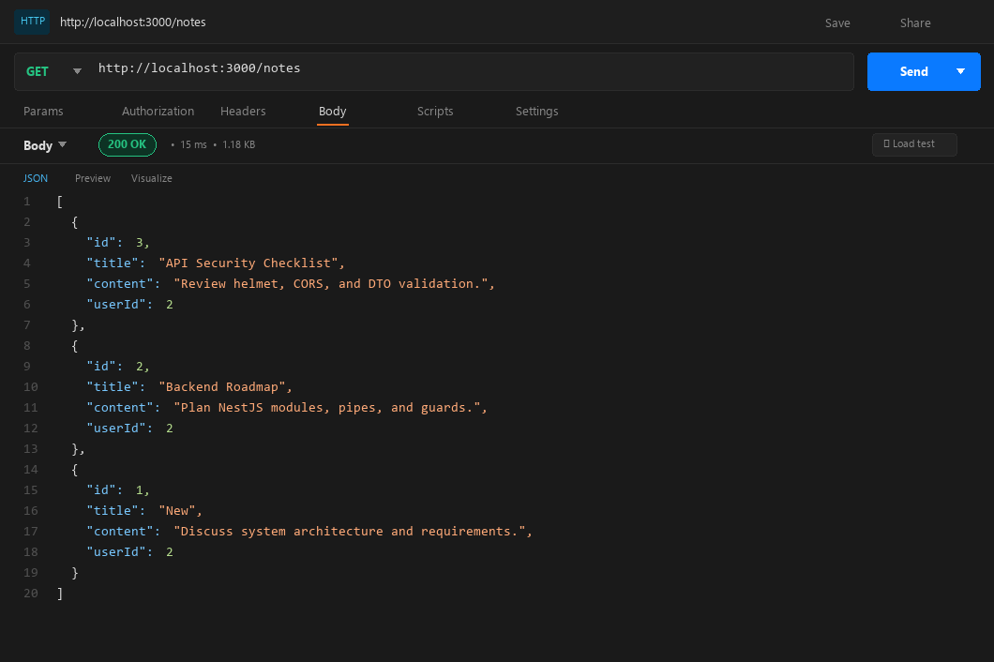
Figure 4.1: GET /notes — 200 OK, notes sorted ascending by title (default)
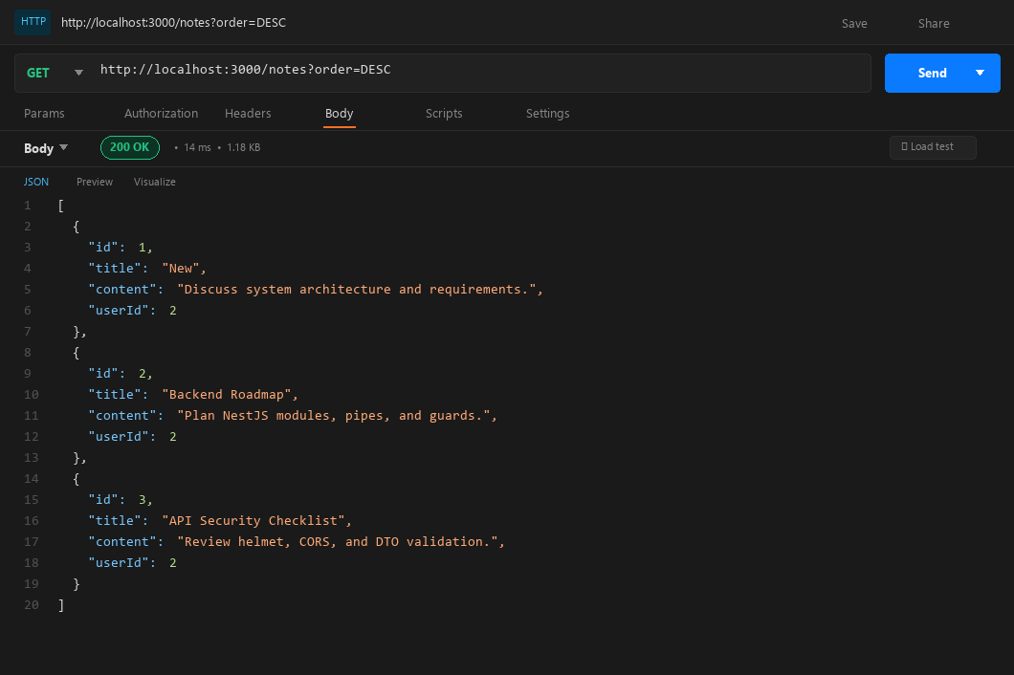
Figure 4.2: GET /notes?order=DESC — 200 OK, notes sorted descending by title
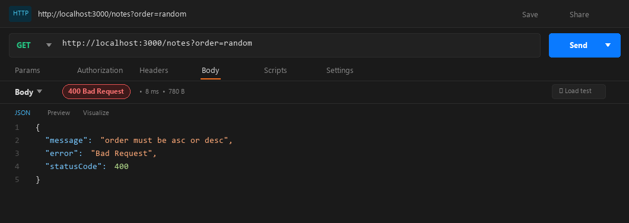
Figure 4.3: GET /notes?order=random — 400 Bad Request, 'order must be asc or desc'
Task 5: Authentication, Change Password (4 Marks)
POST /auth/change-password protected by AuthGuard. Validates current password via bcrypt.compare, rejects same new password, enforces password complexity, and updates the hash. Response never includes passwordHash.
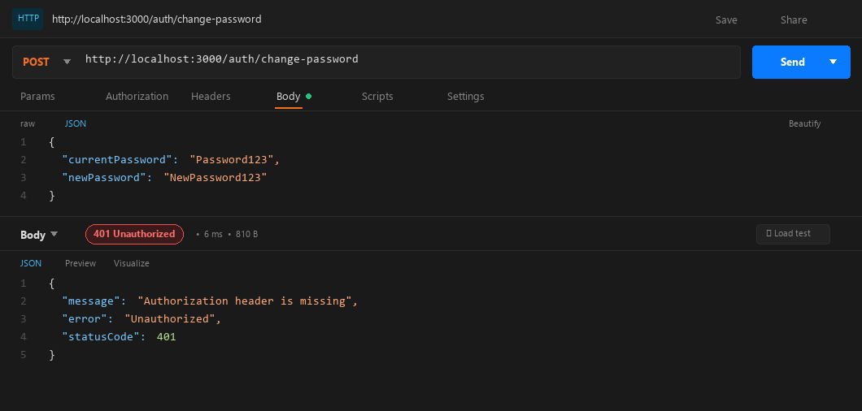
Figure 5.1: POST /auth/change-password with no token — 401 Unauthorized (Authorization header is missing)
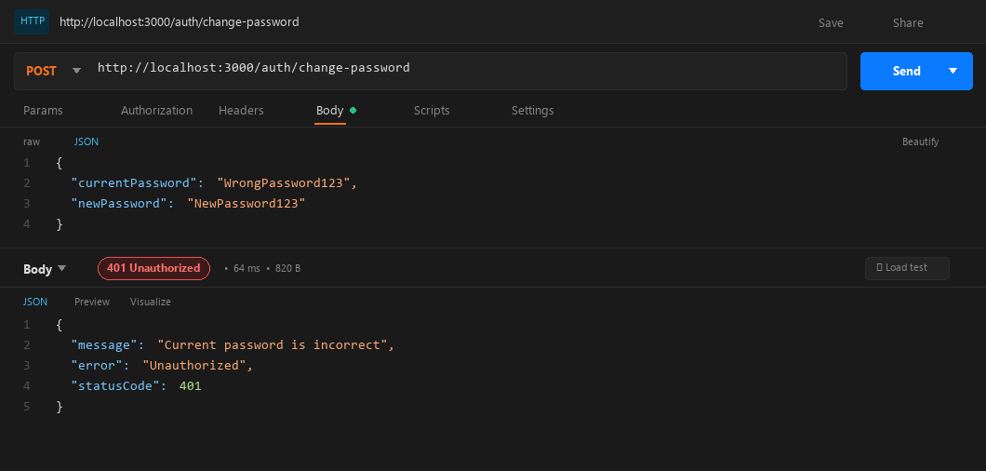
Figure 5.2: POST /auth/change-password with wrong current password — 401 Unauthorized
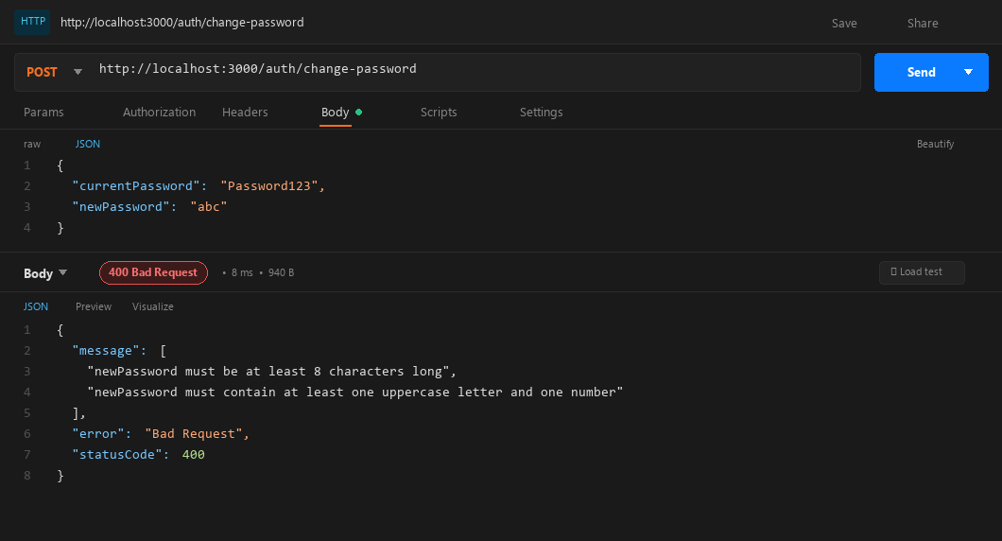
Figure 5.3: POST /auth/change-password with weak newPassword ('abc') — 400 Bad Request (validation errors)
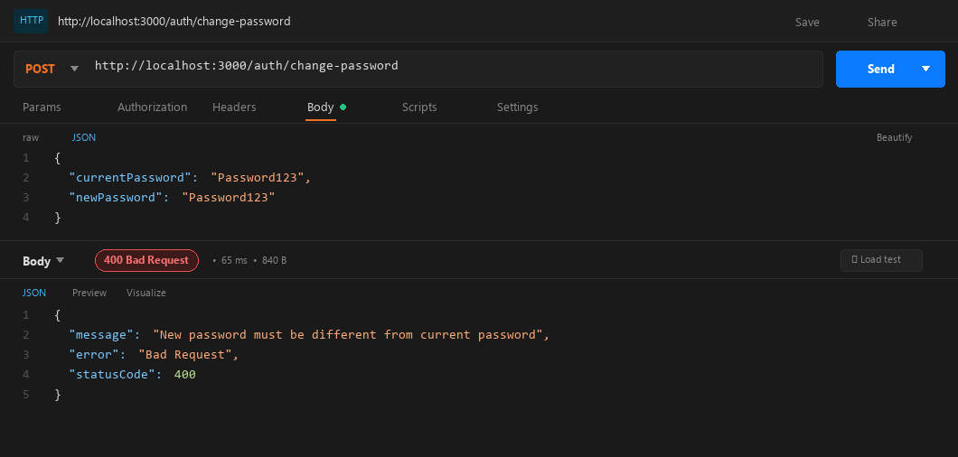
Figure 5.4: POST /auth/change-password with same new password — 400 Bad Request
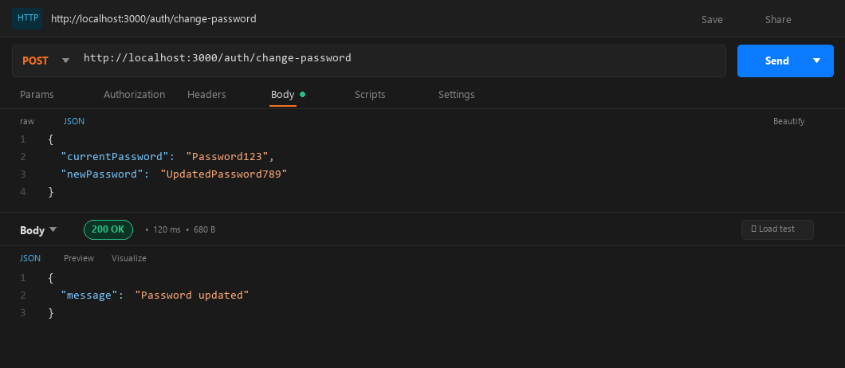
Figure 5.5: POST /auth/change-password with valid credentials — 200 OK, {'message': 'Password updated'}
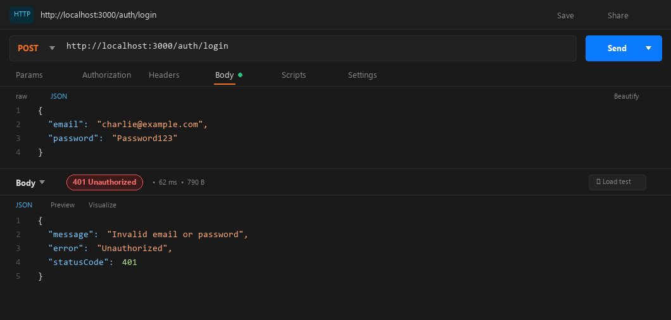
Figure 5.6: POST /auth/login with the old password after change — 401 Unauthorized
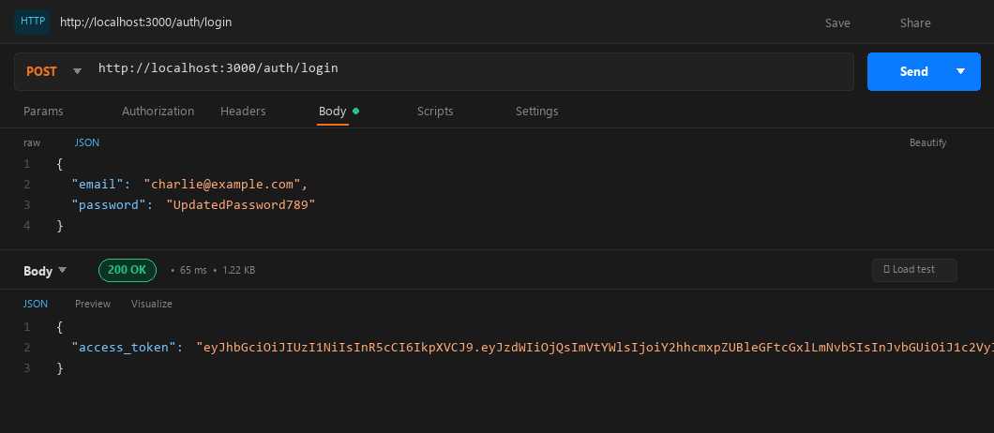
Figure 5.7: POST /auth/login with the new password after change — 200 OK, JWT token returned
Task 6: Authorization, Admin Users List (3 Marks)
GET /users protected by @UseGuards(AuthGuard, RolesGuard) and @Roles('admin'). Returns sanitized user objects (id, name, email, role) — passwordHash is never sent to the client.
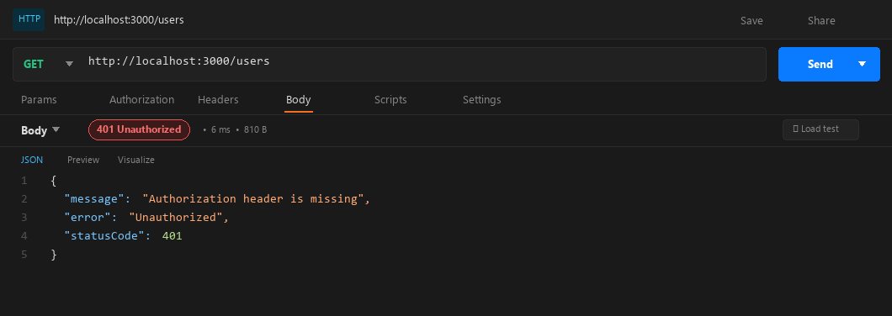
Figure 6.1: GET /users with no token — 401 Unauthorized
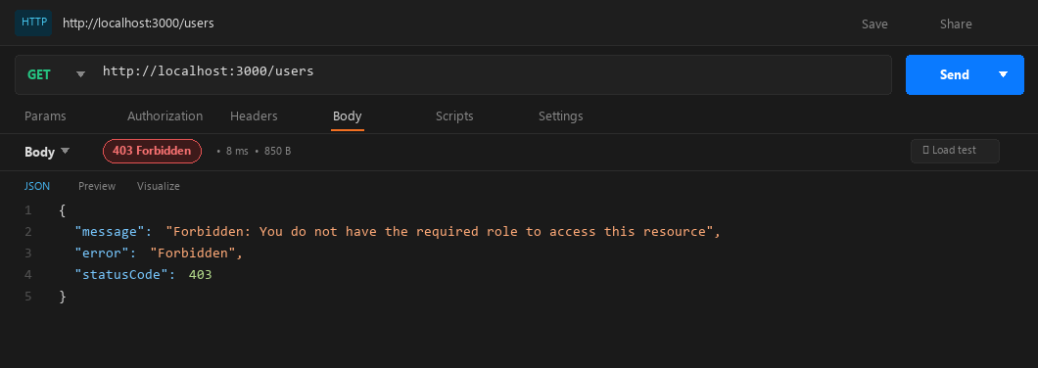
Figure 6.2: GET /users by regular user (Bob) — 403 Forbidden (RolesGuard blocks non-admin)
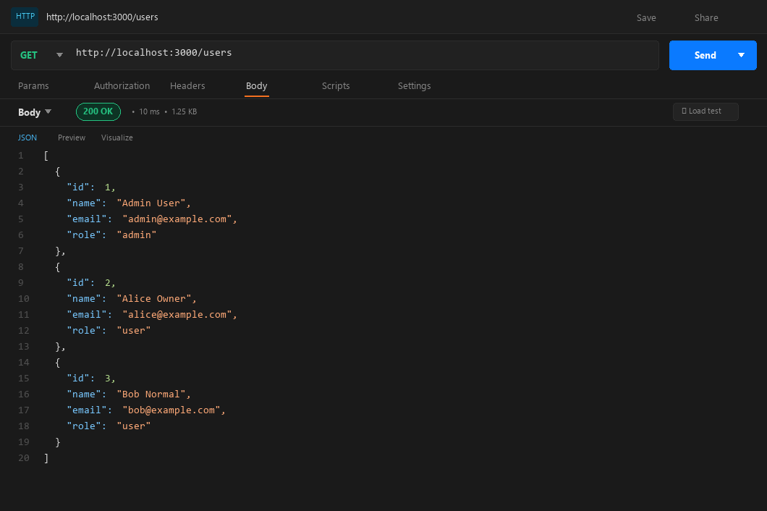
Figure 6.3: GET /users by admin — 200 OK, all users listed with no passwordHash field
Reflection Questions & Answers
Concise conceptual explanations for the viva questions.
1. What is the difference between a 401 and a 403 response?
401 Unauthorized: authentication is missing or invalid (unverified identity). Example: calling GET /notes without a Bearer token.
403 Forbidden: authenticated but lacks permission. Example: a normal user calling GET /users or patching another user's note.
2. Why must validation happen on the server even when the front end already validates?
Client-side validation can be trivially bypassed using curl or Postman. Server-side validation is the authoritative security boundary that enforces schema rules and protects backend logic.
3. A JWT payload is readable. Why is the token still safe?
The payload is Base64Url-encoded but cryptographically signed. Any tampering with the payload invalidates the signature, which the server detects immediately via jwtService.verify().
4. Why does login return the same error for wrong email and wrong password?
To prevent user enumeration: distinct messages would reveal which emails exist on the platform, enabling targeted attacks. A generic 'Invalid email or password' prevents this.
5. In what order do middleware, guards, and pipes run? Why must AuthGuard come before RolesGuard?
Order: Middleware → Guards → Interceptors (pre) → Pipes → Handler → Interceptors (post) / Filters.
AuthGuard must precede RolesGuard because it decodes the JWT and attaches req.user. Without that, RolesGuard has no user object to inspect.

